**CMR Institute of Technology**

**Kandlakoya Village, Medchal Rd, Hyderabad, Telangana 501401**

**Institute Innovation cell**

**Developing Online Repository of Ideas Developed and Wayforward plan**

**Team Name:** Blind Guide

Members:

1.D.Devendar.[20R01A0469]

2.G.Umesh. .[20R01A0475]

3.P.Ravi kiran. .[20R01A04A0]

4.G.Rakesh. .[20R01A0474]

5.E.Emmanuel joshua. .[20R01A0470]

6.A.Sahith. .[20R01A0461]

Idea Title: optimisation of laptop charger

Problem Statement:

**TO PREVENT RAPID DRANING OF ELECTRICITY IN LAPTOP CHARGERS**

# OVERVIEW

We are creating a charger which can be used for both mobile as well as laptop. Which will not effect the battery performance.

# GOALS/Objectives

1. To simplify the laptop charger without effecting the battery performance of electronical device.
2. Creating only single charger instead of two chargers or cables.

# SPECIFICATIONS

The charger we are creating is a single charger used for both mobile and laptop, which reduces the cost efficiency. Reduces the size as one charger,

# 

# MILESTONES

## Ideation/Data collection

So many people are facing problem with laptop charger with cost ,size. When they are moving out to carry two charger is very difficult .

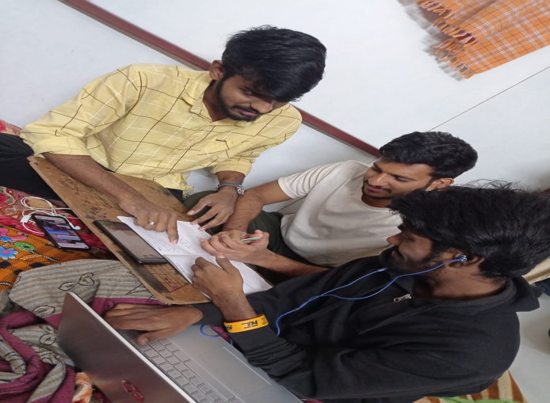

Fig:problemsinario

## Model Building

To convert the two chargers in to one we attaching one of the transformer to the adaptor and making swithing out of the adaptor the connection are given below:

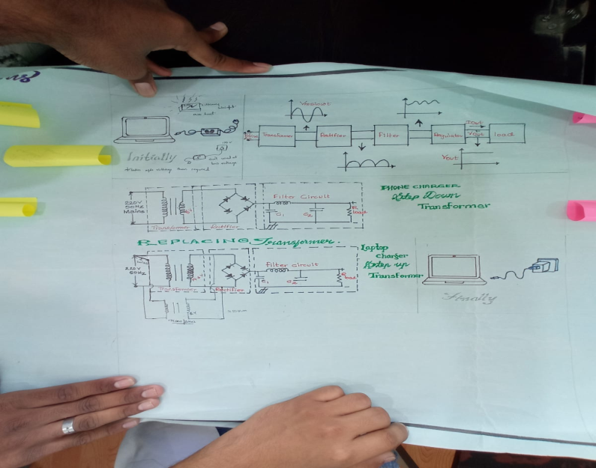

Fig 2 Model or blueprint: ______

## Components/Tools Understanding and usage

Laptop charger : These is used to make connection in it to attach transformer to it.

phone charger : we will take the transformer in it and attach to the laptop transformer.

switch ,wires etc….,

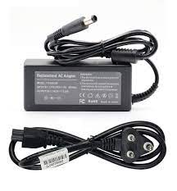

Fig 3.1: Component 1

Laptop charger

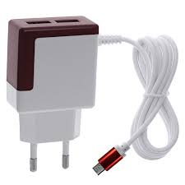

Fig 3.2 : Component 2

Mobile charger

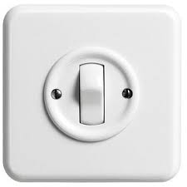

Fig 3.3: Component 3

switch